AVONLEA SCHOOL

BOX 330 AVONLEA, SK S0H 0C0
Phone: (306)868-2000 Fax: (306)868-2280

Avonlea bus drivers take the safety of every student on their bus seriously. For this reason they ask that you please review this package together as a family, and in particular remind you of the following:

Guest Riders on Avonlea Busses:
Avonlea School and Bus drivers ask that any family requesting a child ride home with a bus student either write a note in the agenda or phone the school in the morning. We will also be confirming with the host family that this arrangement has been made. It is important to remember that last minute arrangements are very hard to confirm and can result in too many students wanting to ride an already full bus. For this reason we ask that all prearrangements be cleared with your driver, and any group activities, such as Birthday Parties, have at least one week notice.

Proper Clothing:
It is imperative that students are prepared with boots, winter jackets, mittens and hats when riding the bus. In the event of a breakdown, students may have to evacuate the bus and be outside for an indeterminate amount of time. It is fine to pack the necessary items and carry them rather than wear.

Sports and Other Equipment:
Sporting equipment must be stored safely during the ride. Hockey sticks will be secured according to the driver’s direction. Balls, skates, etc. must be kept in a bag. Depending on the size of the items and space on the bus, the driver may choose to store them in an alternate space. If you are sending large items or difficult to store items such as golf clubs, please discuss with your bus driver first.
Impassable Roads:
If due to poor road conditions the bus is unable to get to your home, they may ask you to transport your child(ren) to a safe pick up spot along their route.

Food on the Bus:
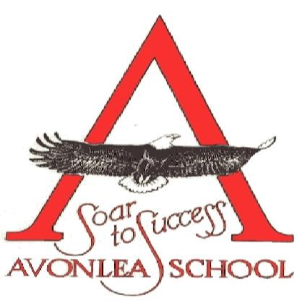
There is always a worry about choking, as the roads can sometimes be rough and drivers may not notice a student in distress. The drivers know that sometimes mornings are rushed and if on occasion breakfast comes with the student, they try to accommodate. School is happy to accommodate as well, and given notice (i.e. a phone call) can make sure students have eaten prior to starting their day. Water bottles are encouraged on the bus, but canned or boxed drinks are not to be opened on the bus.

/continued

Page 2

======================================================================

Safety around Bus Parking at the School:
The bus lanes are for busses only between 8:15 and 9:15 am, and from 3:00-4:00 pm. Please do not use the bus lanes to drop off or load up students. You are welcome to pull into the gravel lot beside the school if you are with a group.
All students not boarding the busses are asked to walk through at the front of the bus lanes or the rear. Please do not walk between busses parked in the lane. If you are picking up a child, it is requested that you walk across the street and walk them to your vehicle, as small children are harder to see, and a few times drivers have started to pull out, not noticing the parent gesturing a child to run across the street.

Thank you for reviewing these important items, and for supporting our drivers in providing the safest possible ride to your children.

Sincerely,
Charla Luther
Principal, Avonlea School
1(306) 868-2000 work
1(306) 519-3265 cell luther.charla@prairiesouth.ca

