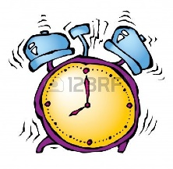
School Times

7:30 – 8:20 Breakfast Program
8:00 – 8:20 Supervision Outside
8:20 – 8:51 Period 1
8:51 – 9:22 Period 2
9:22 – 9:55 Period 3
9:55 – 10:10 RECESS
10:10 – 10:39 Period 4
10:39 – 11:10 Period 5
11:10 – 11:55 LUNCH
11:55 – 12:26 Period 6
12:26 – 12:57 Period 7
12:57 – 1:30 Period 8
1:30 – 1:45 RECESS
1:45 – 2:14 Period 9
2:14 – 2:45 Period 10
2:45 – 4:00 ** After school program (application forms available at the school)

Pre-Kindergarten: Full days on Days 2, 4 & 6
Kindergarten: Full days on Days 1, 3 and 5

