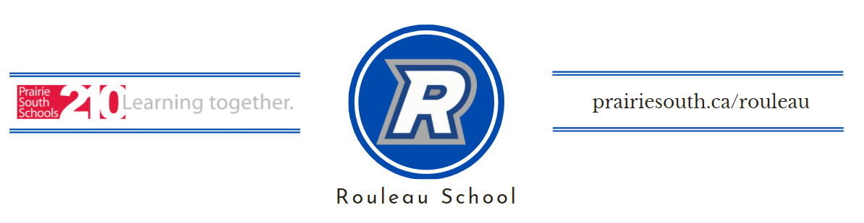

Dear Rouleau School Community October 14, 2022

Rouleau School is seeking community support for our upcoming projects. This Fall and Winter we plan to continue the revitalization of our school spaces. In the gym, we plan to replace our entrance doors, stage/end wall padding, improve our stage lighting and purchase an AED. Additionally, we plan to replace our trophy cabinets and complete some projects on the exterior of the school. Any additional funds raised would be used to further support student activities and programs.

Over the past decade we have completed many revitalization projects including new volleyball standards, playground basketball net, playground backstop, repainting the gym, purchasing snowshoes and archery equipment, installing a Rebel mural, updating provincial banners, and the installation our live streaming kit sponsored by Hockey and Hearts. Our largest projects have included refinishing our gym floor and the installation of our outdoor digital sign.

Over the past year, our library, computer lab, and many classrooms have been partially or completely renovated. Thanks to the success of our recent Prairie South Development Matching Grant application and the support of Westrum Lumber, Harvard Western Insurance, Crop Intelligence, Young’s Equipment, and our SCC, we were excited to see the installation of our outdoor digital sign.

Combined with our Summer 2021 and summer 2022 projects, these new spaces have provided enhanced experiences for our students and promote a culture of pride and excellence at Rouleau School. We take pride in the level of education our students receive and the additional opportunities our students enjoy outside the classroom. This year, 100% of our teachers have been involved in an extra-curricular activity and 85% of our 7-12 students (46/54) have already participated in activities including golf, cross country, volleyball, and SRC so far this year.

Those who wish to support our upcoming project will be recognized on a new sponsorship sign in the school and in the gym. Sponsors can be recognized as family names, company names, or with your company logo. Sponsors will be recognized at the following levels:

Platinum Sponsors ($5000) Gold Sponsors ($2500)
Silver Sponsors ($1500) Bronze Sponsors ($500)

This Fall, we call on all those who have benefitted from Rouleau School’s curricular and extra-curricular programs, as well as all those who expect to benefit from them in the future. Any support is appreciated. We look forward to hearing your response.

Mitch Singleton
Principal
Rouleau School (306-776-2332)

