Westmount School – March Newsletter
March 6th – LIT/Teacher Prep Day
(No School)
March 10th – Ski Trip (Boyle, Krukoff, Hack)
March 12th – Progress Reports available on
My School Sask Parent Portal
March 17th – Green and Gold Day
March 18th – Grade 8 Farewell Photos (a.m.)
March 23rd – LIT/Early Dismissal (2:30 p.m.)
March 24th & 26th – Student Led Conferences

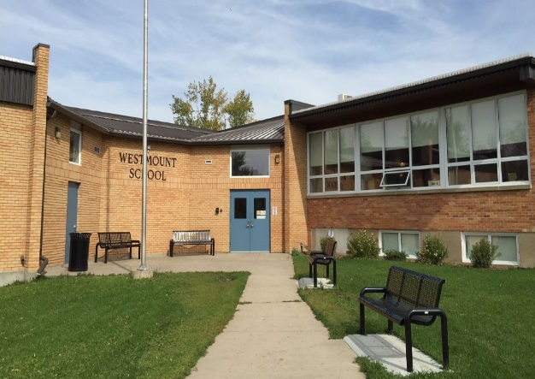

School Hours
Morning | Afternoon | To ensure student safety, supervision is provided 15 minutes prior to the entrance bell in the morning and 10 minutes after the dismissal bell at the end of the day.
9:00 Entry Bell | 12:35 Entry Bell
9:05 Classes Begin | 12:40 Classes Begin
11:55 Lunch | 3:30 Dismissal

Our current mantra – Mistakes are opportunities for learning!
How often I found where I should be going
only by setting out for somewhere else.
-R. Buckminster Fuller

Farewell and Welcome
Farewell Ms. Hofer and Mrs. Antonio. Ms. Hofer is off on maternity leave and Mrs. Antonio has resigned to take a trip home to visit family. We wish you both the best of luck!
Welcome to our two new Educational Assistants Mrs. Jayla Brinkworth and Ms. Marlain Watson! Mrs. Brinkworth is replacing Mrs. Antonio and Ms. Watson is replacing Ms. Hofer. As well, welcome Ms. Callie Overs, an Educational Assistant practicum student who will be working in Mrs. Wiebe’s grade ½ classroom during the month of March.
Student Progress Reports
Term 2 Progress Reports for students in kindergarten to grade 8 will be uploaded to the My School Sask (MSS) parent portal on Thursday, March 12th.
If you provided the school with a valid email address, you would have received information from the school about how to log in to your portal so that you can view your child(ren)’s progress. This will allow you to view progress reports and other information. While schools will be happy to print progress reports in unusual circumstances, we expect that the portal information will take the place of the traditional printed report card as we move forward.
To access the portal, go to https://myschoolsask.ca/aspen/logon.do If this is your first time logging on, please do so from a computer and not a smartphone. If you are not able to access the parent portal or you forgot your password, please contact Mr. McIntosh (mcintosh.angus@prairiesouth.ca).

March Student-Led Conferences
What is a Student-Led Conference?
A student-led conference is a preplanned meeting in which students demonstrate responsibility for their academic performance by providing a review of their work for parents and teachers. The students lead the conference by presenting work samples and discussing their learning.
Student-led conferences differ from the traditional parent/teacher conferences.
- Students participate in all stages of the conference. They prepare and organize work samples, use checklists to demonstrate new learning, and plan next steps.
- Students lead the conversation to show what they have learned. They receive feedback from their parents and teachers about strengths and goals for improvement.

Student-led conferences benefit students, parents, and teachers.
- Students take more ownership of their learning.
- Parents and students have open communication about school, after-school activities, and other important decisions in life.
- Teachers establish a stronger working relationship with parents and students.
Student-Led Conferences will take place on March 24th and 26th from 4:00 p.m. – 7:30 p.m. We will continue to book conferences through an online booking system. Please visit the school website or Facebook Page the week of March 9th to access the link. Don’t have online access – please phone the school and we will schedule you in!

Mrs. Flegel has been hard at work weeding through the books in our Learning Commons. During Student Led Conferences we will be selling used books for $1.00 each. All proceeds raised will go towards purchasing new books for our library.

Kindergarten Registration
Kindergarten Registration is now open for the 2020-2021 school year. Please bring your child’s birth certificate and Saskatchewan health card.
Information on Pre-Kindergarten applications will be communicated via Facebook and the school website as soon as we know more!
 | High School Tours & Registration
 | SCHOOL TOURS & PARENT INFORMATION NIGHT  FOR ALL MOOSE JAW PUBLIC HIGH SCHOOLS  (A.E. Peacock, Central, Riverview)  Monday, MARCH 16, 2020  5:30 pm – 9:00 pm |  | This event is for all grade 8 students and their parents/guardians. The purpose is to provide information to assist your decision in high school registration for the 2020-2021 school year.  If you have questions, please contact your local school or the high schools

Mother's Day Trade Show
Westmount School Generosity Club
Westmount School Gym
1100 Currie Cres. Moose Jaw
Saturday, May 2, 2020
10 a.m.-3 p.m.
5ft Tables for $40
Additional tables $20 each
Contact – Mrs. Taylor-French

Optimist Pancake Breakfast
A huge thank you to the Moose Jaw Optimist Club and their sponsors for providing and hosting a fabulous pancake breakfast on Day of Pink. The breakfast was delicious, and we really appreciated it!
Become a member – This year’s School Community Council Annual General Meeting and Elections will be held on April 28th at 7 p.m. in the Westmount School Library. More information regarding the elections will be included in the April newsletter.
Westmount School Goals 2019/2020
By June 2020, 90% of students in grades 1 – 8 will be reading at or above grade level as measured by F&P or BRI. | By June 2020, 65% of students in grades 1 – 8 will be writing at or above grade level as measured by the holistic writing rubric.
Outdoor Jets is an extra-curricular club that Westmount had a couple of years ago and was named by the students in the club. The club enjoyed playground visits and walks in the neighborhood, crafts and educational activities as well as visits at Extendicare. We have lots of fun and exciting adventures planned for this year and we hope that more Westmount students will join us. We aim to be outdoors as much as possible, so we ask that students come dressed appropriately.

This club is open to students from Pre-K to grade eight. Parents and younger siblings are welcome to join us. Kindergarten and Pre-Kindergarten students must be accompanied by an adult in order to be sure we have enough supervision for these opportunities.

Please remind your child(ren) that coming to any extra-curricular activity is a privilege. If a student is misbehaving, they will be given a warning. If the behaviour continues, they will be sent home with a phone call to their parents. If this is a regular occurrence a parent will be asked to either accompany them or to not send the student(s).

Outdoor Jets will be on Wednesdays from 3:30-4:30 on the following days:
March 11, 18, 25
April 1, 22, 29
May 13, 20, 27
June 3, 17

If any parents wish to volunteer their time and provide a nature based activity for the club or have an idea for us, please contact Mrs. Alexanderson during school hours at 694-5999 or by email at alexanderson.kim@priariesouth.ca.

We are also planning on regular outings into our school neighbourhood and to do so we need parental consent for all students who are not accompanied by an adult.

Hope to see you there!
Mrs. Fortin, Ms. Hack, Mrs. Topp & Mrs. Alexanderson

Outdoor Jets Permission Form
(please detach and return if your child is interested in participating)
-------------------------------------------------------------------------------------------------------------------------------

________________________ may participate in all events related to Outdoor Jets!
(student’s name)

I understand that there are risks present when participating in physical activity and off-site excursions and I agree that exposing my child to such risks is reasonable in order that they
have this experience.

Grade: ______________ Homeroom Teacher: ________________________________

Parent Signature: ________________________ Date: _____________________

Parent Contact Information:
Name __________________________________ Phone #: __________________

Emergency Contact Information (in the event we cannot get a hold of the parent contact):
Name __________________________________ Phone #: __________________

